Inclusivity policy
Version January 2026

Introduction and goal of inclusiveness policy
Since its establishment, TARAIC has been advocating for a humane and just world - against poverty and social exclusion, for solidarity and empowerment. TARAIC collaborates with dedicated, humanitarian-minded people and organizations working to overcome social problems.
In our work, we support individuals and groups who are marginalized or underrepresented, and their needs, interests and rights guide our activities, projects and partnerships. Together with vulnerable people, we create conditions that will enable them to face challenging situations, empowered. Equality and equal opportunities for all people are central prerequisites for overcoming poverty and social inequality.

Frame
This policy applies to all TARAIC employees involved in the formulation, management, monitoring and evaluation of projects. It also applies to consultants, contractors or any third parties involved in such projects, as well as natural and legal persons associated with our relevant partner organizations at home and abroad.

Policy statement
We are committed to respecting and promoting internationally recognized human rights in all our activities - human rights for all, regardless of ethnic origin, religion, disability, age, gender, sexual orientation, socio-economic or other status. The inclusion and equality of diversity, actively opposing all forms of discrimination, and promoting an inclusive society are the main goals of our work.
This commitment is based not only on the human rights framework but also on globally agreed principles such as those contained in the UN Conventions on the Rights of Women, the Rights of the Child and the Rights of Persons with Disabilities. With this policy, we also contribute to the implementation of the global aspirations set out in the UN Sustainable Development Goals (SDGs), especially Goal 1 (poverty reduction), Goal 5 (gender equality), Goal 8 (decent work), Goal 10 (reducing inequality) and Goal 16 (peace, justice and strong institutions).
Through this commitment, we create an inclusive, safe and human rights-compliant environment for our staff and the communities/groups and individuals we serve, especially those most vulnerable to exclusion.

Data protection
Personal and confidential data of employees, clients and partners of TARAIC are treated in accordance with legal regulations and are protected from abuse, theft and unauthorized access. Information will only be disclosed if required or expressly permitted by applicable laws and regulations.

Work-life balance
TARAIC is committed to protecting employees' work-life balance as a key element of their health, safety and well-being. Managers must organize work to avoid excessive hours, unrealistic deadlines and continuous availability outside working hours, and employees have the right to opt out of business communication outside agreed working hours, except in genuine emergencies. Employees may request flexible working arrangements (such as flexible working hours, telecommuting or compressed weeks) and reasonable leave related to parental or caring responsibilities and will not suffer any harm or discrimination for making such requests or using these provisions, subject to applicable EU and national work-life balance legislation.

Gender balance in leadership and decision-making
TARAIC is committed to promoting gender balance in leadership and decision-making processes at all levels of the organization. To this end, the organization will strive for a balanced representation of women and men in management structures, project teams, advisory bodies and selection and appointment procedures, with the application of transparent criteria based on competence, experience and equal opportunities. Special attention will be paid to removing structural and cultural barriers that may limit the advancement of women or other underrepresented groups, including gender stereotypes, uneven distribution of unpaid responsibilities and unequal access to professional development. TARAIC will, where applicable, monitor the gender structure in governing and decision-making bodies and take corrective action when significant imbalances are identified.

Integration of the gender dimension in research and/or teaching contents
TARAIC will systematically include the gender dimension in the planning, implementation, monitoring and evaluation of its research, educational and program activities when relevant to the topic and target group. This means that when preparing analysis, training, publications, methodology and teaching content, it is considered how gender affects experiences, needs, access to resources, benefits and outcomes for different groups of women and men, as well as for people of different gender identities. Wherever possible and appropriate, gender-sensitive data, examples, language and indicators will be used to avoid reproducing stereotypes and ensure content is relevant, fair and inclusive. Employees and collaborators will be encouraged to develop knowledge and capacities for applying a gender-responsive approach in research, learning, training and communication.

Responsibility
TARAIC management is responsible for the implementation of this policy. The policy is implemented by all employees.

Complaints mechanism
In cases of suspected violation of this policy, TARAIC management will take action. Depending on the nature and urgency of the complaint, the matter may be resolved in one or more confidential meetings, or it may be necessary to consult professional services.
The management of TARAIC is obliged to keep confidential the personal circumstances of employees that have become known to them, as well as matters that, due to their importance or content, require confidential treatment.

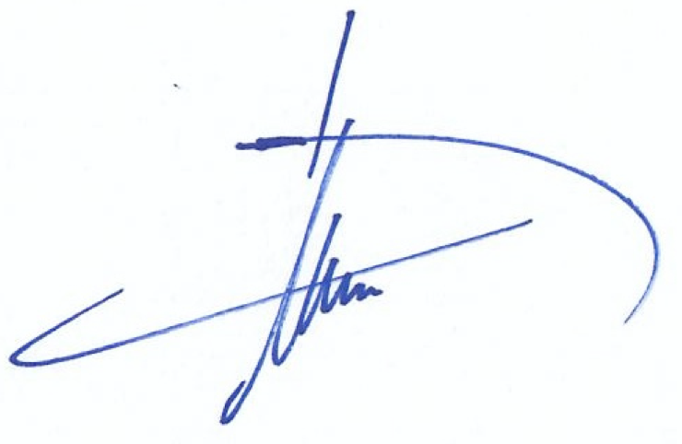

Dr.sc Hugo A.M. van Veghel
Director

