Child protection policy

Version March 2024

Introduction
TARAIC has adopted this document with the aim of developing awareness and creating a basis for the action of all employees in relation to child protection. A child is a person under the age of 18 (at the age of 18 or younger).
The child protection policy informs all employees, associates and volunteers about the rights of the child according to the UN Convention on the Rights of the Child, as well as internal policies. It is presented to all TARAIC employees upon entering the organization, who confirm familiarity, consent and implementation by signing. The content of the policy is mandatory for all employees, volunteers, casual workers and freelancers .
The content of the document is based on the "Child Protection Policy" document of the partner organization Volkshilfe from Austria.

2. Objectives and principles

2.1. Objectives of the Child Protection Policy
The goal of the Child Protection Policy is to ensure compliance with child protection laws in TARAIC projects and to contribute to the protection of children from abuse, neglect and all other forms of violence, both physical and psychological. It is intended to strengthen the awareness of this topic among all employees and associates and to develop, among employees, awareness and the basis for action related to the treatment of children in their daily work.

2.2 UN Convention on the Rights of the Child
The United Nations Convention on the Rights of the Child defines the protection and realization of children's rights for all children; defined aspects aim to ensure a good life for children. TARAIC's child protection policy is based on 54 articles of the UN Convention on the Rights of the Child, which are summarized in ten basic principles:
1. The right to protection from discrimination based on religion, origin, disability and gender.
2. The right to a family, parental guidance and a safe home.
3. Right to privacy and non-violent upbringing.
4. The right to education and to free time, play and recreation.
5. The right to a healthy diet, health care and housing.
6. The right to support, so that children with disabilities can live an independent life in society.
7. The right to immediate assistance in case of accidents and emergency situations, as well as protection from neglect and exploitation.
8. The right to information, communication in the mother tongue, assembly and expression of culture and religion.
9. The right that the best interests of the child must come first in all decisions.
10. Children's right to be heard and to have their opinion respected.

Based on the UN Convention on the Rights of the Child, the protection of children in TARAIC includes preventive and reactive measures against exploitation, neglect and emotional and physical abuse. In this spirit, with its Child Protection Policy, TARAIC undertakes to create a protective environment for children and young people and to actively respond to deviations from children's rights.

The following articles from the UN Convention on the Rights of the Child are particularly important for TARAIC:
Art. 2: All children have the same rights; discrimination of any kind is prohibited.
Art. 3: The best interests of the child must come first in all measures.
Art. 12: In all measures affecting children and young people, children should be given the opportunity to form their own opinions, and the child's views must be taken into account.
Art. 16: The child's privacy must be protected by all measures. In addition, with regard to data protection, guidelines have been developed for the anonymization of collected data and their adequate processing, taking into account the best interests of the child.
Art. 19: The current Child Protection Policy applies to protection from violence, abuse or neglect.

In general, the task of the organization is to advocate for children's rights and children's well-being in society .

3.Prevention

3.1 Direct contact with minors

Daily work at TARAIC does not mean working directly with children every day, but some projects are focused on children and their equal opportunities, which is why it is important that all TARAIC employees and volunteers are trained in how to communicate with children.
In direct contact with children and young people, the first priority is an equal relationship based on respect. This implies the prohibition of any violence, safeguarding the integrity of the child, as well as awareness of the child's privacy. Children's views and concerns must always be taken seriously, and if several children are involved in an activity together, attention and respect should be evenly distributed. These premises must be taken into account when planning projects.
In addition to age-appropriate language, special attention must be paid to the needs of children and parents, especially when communicating with children with special needs or where language barriers exist.
If a violation of a child's rights is suspected, an internal reporting procedure must be applied, as defined in Chapter 4 of this policy.

3.2 Data protection

The provisions of the Personal Data Protection Act of the Republic of Serbia must be respected at all times.

3.3 Media Reports and Campaigns

Communication in the form of media reports, campaigns, contributions on social networks and communication with donors are important elements for contributing to the realization of children's rights and equal opportunities for all children. However, public relations materials containing images of children also carry the risk of violating children's rights. As a result, when creating and sharing media content, the dignity of the depicted children, as well as their identity, must be protected. When working with children who are particularly vulnerable, additional protection measures must be applied. In this context, TARAIC employees envisage the following aspects for media representatives:
• Pseudonyms must be used for children, except when mentioning the name is in the best interest of the child and when it is done with the consent of both the child and the legal guardian.
• Clothing worn must ensure that the child's privacy is protected.
• The privacy of all persons involved in the projects must be respected at all times.
• All media content must be based on the values of equality and respect and must protect the dignity of the persons depicted.
• Children are presented as persons with potential and aspects in an empowered way, and stereotypical and victim roles are reduced or avoided.
• Before compiling media content, children and their legal guardians must be informed about the purpose and intended use of the content and their presentation in an understandable manner.
• When compiling media content, the consent of children and their legal guardians must always be obtained. For general reports, this can be done verbally by the reporter himself or by a project employee. Reports featuring an individual child require more detailed explanations of the purpose and intent of the media content, as well as a written or oral statement of consent from the child and their legal guardians.
• The description of the child's life situation must always represent the context of his economic, social and cultural environment.
• In a public relations context, images must always be chosen to take into account the dignity of those depicted in the report. Reporting must meet the highest standards of child rights described in the Convention on the Rights of the Child.
• Images stored in TARAIC can be used in accordance with the described principles and internal policies of TARAIC. The publication must always take into account the principles of child protection.
In general, the best interests of the child must take priority over public relations. The presentation must be varied and diverse, and children affected by poverty must not be reduced to stereotypes or victims.

3.4 Communication with donors

Donors, foundations and private sponsors are informed about the results of certain projects and the use of donations. In this context, the principles described above also apply and pseudonyms are used. Details that could be used to identify families will never be shared. The results are presented as examples of specific cases, but in such a way that no specific family can be recognized.

3.5 Procurement of advertising material and others

TARAIC gives preference to products that can be transparently demonstrated to be free of child labor in the production process.
When purchasing food or advertising and work materials, they should have a quality seal that indicates "fair" production.

4. Suspected risk to child welfare
TARAIC unequivocally prohibits physical and psychological violence against children.

4.1 Types of risk to children's well-being
TARAIC's child protection policy is oriented towards the following types of abuse:
• Emotional abuse
Emotional abuse means constant emotional maltreatment of a child that can lead to severe long-term consequences for emotional development. This includes causing and reinforcing feelings of worthlessness, fear of being unloved. Excessively high, inappropriate expectations of a child are also considered emotional abuse.
• Physical abuse
Physical abuse means any physically harmful effect on others, including actions such as beating, slapping, throwing, causing burns, pushing, choking, as well as not rendering aid in case of injury or intentionally causing or feigning illness. In general, it must be assumed that any type of physical violence will also have emotional consequences and lead to mental damage.
• Sexual abuse
Forcing or seducing a child to participate in sexual activity is sexual abuse - regardless of conscious perception or consent. This includes penetrative and non-penetrative acts, as well as acts without physical contact, such as seduction, viewing pornographic material or inappropriately encouraging a child sexually.
• Neglect
Neglect means the continued failure to meet a child's basic physical and mental needs. This can seriously damage physical or cognitive development. Basic needs include nutrition, personal care and housing, as well as social networks, education, recreation and more.

4.2 Steps in case of suspected risk to the welfare of children

All employees of TARAIC must report any suspicion of a risk to the welfare of children (if it is determined during their professional activity) to the competent Center for Social Work.
Internally, a suspected risk to the welfare of children is treated confidentially in relation to other employees, until other measures are completed and resolved. The management of the organization must be involved in every case without delay.
The procedure for suspected risk to the welfare of children follows the steps shown in the diagram.

Suspicion evaluation and risk assessment
The two-person principle (the person who identifies the suspicion must carry out the assessment together with the relevant TARAIC staff) |  | Interview with relevant staff of TARAIC
ASSESSMENT
Include professional support, as needed |  | Interview with relevant staff of TARAIC
RESULT
Suspicion not confirmed |  | Suspicion confirmed
INTERVENTION
Documentation: Results report | Conversation with management |  | Report to the competent service + documentation
DOCUMENTATION
Final report

4.3 Task of competent staff of TARAIC
Competent personnel of TARAIC are persons from the management of the organization who are familiar with the UN Convention on the Rights of the Child and with measures for the implementation of child protection in TARAIC. All TARAIC employees are aware of this responsibility.
Below is a brief summary of the procedure and steps required in case of suspicion or report:
• Suspicion against TARAIC collaborators
If an TARAIC employee is suspected, a verbal and/or written report must be submitted to the TARAIC management. The following steps are taken to detect the suspicion according to the flow chart; this is the responsibility of the organization's management. The President must be informed of any case of doubt, and the Board of Directors must be informed of justified doubts.
• Suspicion against the partner organization
If an employee of a partner organization is suspected, the person responsible for the relevant project and TARAIC management must conduct discussions with the partner organization based on the appropriate child protection policy and decide what measures to take. Measures may include suspension of the accused associate. If the partner organization does not implement the measures agreed with TARAIC, the cooperation may be terminated until the case is resolved. In case of abuse of children or young people in a partner organization, the Protection Policy of the partner organization will be applied.
• External doubt
If a person outside TARAIC addresses an TARAIC employee in the context of their professional role and e.g. reports violence or abuse of minors in an environment outside TARAIC, the next steps must be discussed with the competent Center for Social Work.

4.4 Intervention in acute cases
Intervention in acute cases is carried out according to the principle of 2 people together with a colleague or in consultation with the management of TARAIC. In case of acute risk, a report must be submitted to the police and the Center for Social Work.

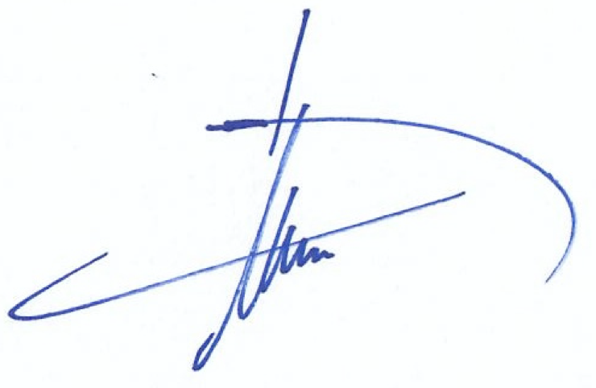

Dr.sc Hugo A.M. van Veghel
Director

