TARAIC Appeals​​ mechanism
Version March 2023
Introduction
TARAIC has been implementing development projects in Serbia since 2010. We strive to adhere to the highest standards of accountability to all stakeholders, including the public, donors, institutions, as well as the people who are the beneficiaries of our aid and projects.
TARAIC is an organization focused on connecting knowledge, innovation and practice through its Science-to-Business (S2B) and Idea-to-Business (I2B) approach. We facilitate collaboration between researchers, innovators, public institutions and business ecosystems, helping to transform ideas into sustainable products, services and development solutions.
We are committed to ensuring that the communities and people we work with have adequate mechanisms for submitting feedback and complaints.

TARAIC's management of feedback and complaints
▪ We ensure that our users have adequate information on how to provide feedback and complaints to us or our partner organizations. This information can be sent directly, during visits to local communities, during the implementation of project activities, through social media or through written communication.
▪ Our staff are trained to respect the people we provide services and support to, regardless of their ethnicity, religion or any other background, and to be receptive and open to feedback and complaints.
▪ We try to offer different ways of submitting feedback and complaints to the people we provide services and support to. Social media and messaging applications have become an increasingly important tool for customer interaction, including feedback and complaints. Our staff also receives feedback and complaints during visits to communities or during the implementation of project activities. Our staff is also open to receive users and other interested parties in our office where they listen and respond to their feedback and complaints. Complaints can also be submitted anonymously by mail or PTT mailbox.
▪ We will accept feedback and complaints from all stakeholders, including the general public, our donors, project beneficiaries, suppliers and others.
▪ Feedback and complaints are treated confidentially and discussed only with those who should be involved in their resolution. Staff members who violate confidentiality principles in bad faith may be subject to disciplinary action.
▪ We are committed to responding to feedback and complaints in a timely manner.
▪ Complaints are investigated and relevant internal and external stakeholders are involved, as appropriate. For complaints related to financial matters or suspected fraud, this may include financial staff and/or auditors.
▪ Serious complaints regarding potential fraud or corruption, or complaints involving suspected sexual exploitation and abuse, are always escalated to TARAIC senior management. Feedback on project activities and non-serious complaints will be handled at the appropriate level. For example, complaints about the inclusion/exclusion of project users and the timing and nature of project activities are usually best handled at the project manager level.
▪ TARAIC regularly reviews this policy.
▪ If a criminal offense is discovered in the report, it will always be reported to the competent authorities.

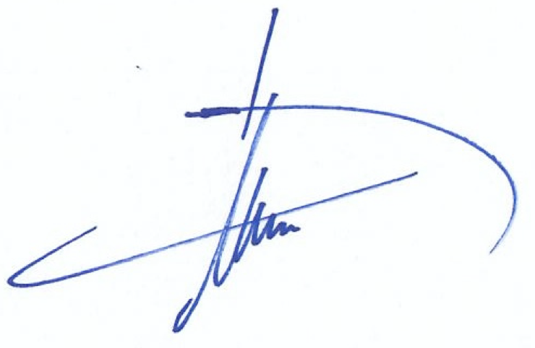

Dr.sc Hugo A.M. van Veghel
Director

