Anti-corruption policy
Version: Jan 2026
Introduction
Misuse of financial and other resources or abuse of power undermines our values and our efforts to empower and support vulnerable and marginalized people. Resources for development projects are scarce and must be used in the most efficient way possible. Corruption takes valuable resources away from the poor and marginalized. It also undermines our reputation, that of our partners and the development sector as a whole. Corruption can negatively affect public support and willingness to donate. It can also pose a legal risk, especially in areas where corruption is legally sanctioned. We are therefore committed to doing everything in our power to prevent corruption and to act effectively and transparently when it occurs.

Frame
This policy applies to all TARAIC employees involved in the formulation, management, monitoring and evaluation of projects. It also applies to consultants, contractors or any third parties involved in such projects, as well as natural and legal persons associated with our relevant partner organizations at home and abroad.

Definition
Corruption is defined as abuse of power for private gain. It covers conduct such as bribery, fraud, extortion or collusion. This includes offering or receiving loans, gifts, fees, rewards or any other advantage to or from any person, as an improper inducement to do something in order to obtain money, sexual favors, employment, business or any other benefit.
In the context of TARAIC's work, this may include inter alia:
▪ Soliciting or accepting gifts, such as money, or any other favors from private businesses for providing the opportunity to supply goods or services for projects.
▪ Soliciting or accepting gifts or any other services from candidates for employment or consulting services in projects.
▪ Requesting or accepting gifts or any other services from persons for their inclusion in the project as a beneficiary.
▪ Soliciting or accepting gifts or any other favors from government or local administrative officials for offering project services in a particular community or region.
▪ Offering gifts to government officials for processing paperwork such as permits.
▪ Requesting sexual services from beneficiaries or potential beneficiaries for their inclusion in the project or provision of humanitarian aid.
▪ Acceptance of sexual services offered by users or potential users.
▪ And so on.

Our obligations
1. TARAIC does not tolerate corruption among any of its employees, consultants or contractors or employees.
2. TARAIC employees, consultants and contractors will never offer bribes or pay bribes, ask for bribes or receive bribes in the course of business in the context of project implementation.
3. TARAIC management leads by example and is committed to promoting awareness of corruption and anti-corruption measures and a sense of responsibility among all staff.
4. TARAIC employees, consultants and contractors shall report any form of corruption or attempted corruption to their superiors.
5. The management of TARAIC will investigate and act on each reported case of corruption.
6. TARAIC employees who violate this policy or fail to report cases of corruption will be subject to disciplinary action, including termination of employment. Third parties such as consultants or contractors who do not comply with this policy will have their contracts terminated. TARAIC may also seek restitution, prosecution or other legal remedies.
7. TARAIC facilitates the prevention and detection of corruption by implementing feedback and complaint mechanisms, through which sensitive complaints such as corruption cases can be safely reported and resolved.
8. TARAIC will assess the risk of corruption for each project during the project formulation phase and implement appropriate risk mitigation measures.
9. TARAIC will monitor corruption risks for each project and adjust response measures when necessary.
10. TARAIC will ensure that all employees, consultants and contractors are aware of this policy.

Anti-corruption measures
1. Access control is established for the payment and financial management system.
2. All financial flows between TARAIC and its external partners are regulated by written contracts.
4. All projects are subject to a multi-stage payment approval procedure. Projects also include periodic reporting and updated financial projections.
5. Bank transfers are subject to the principle of four eyes. After registering the payment in the internal system, two staff members are required to approve bank transfers.
6. Internal procurement procedures include the request to obtain multiple bids depending on the value of the procurement of goods or services. These procurement procedures are specified in all project contracts.
7 . Travel expenses for staff members require the approval of the project coordinator / manager as well as TARAIC management.

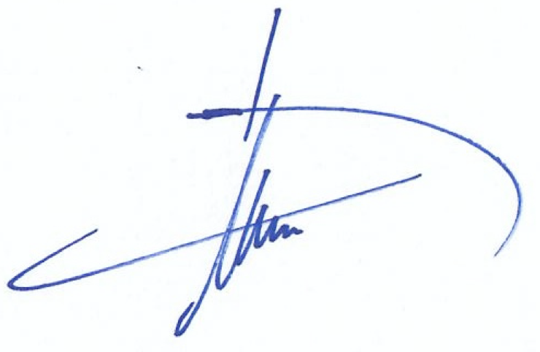

Dr.sc Hugo A.M. van Veghel
Director

